**Q.Design a system for a red colored magical heart pendant that blinks 60 times a minute and stops blinking and turns blue during night.**

Solution proposed : Considering two leds red and blue placed in a heart pendant and the following circuit associated with it for its proper variation of leds dependant on light based on ldr principle and the code mentioned below.

Circuit Diagram

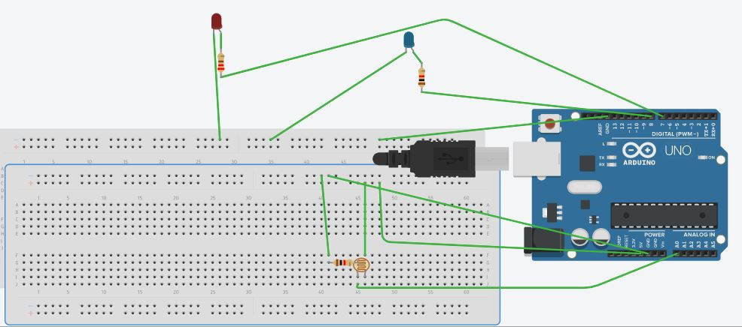

Theory

Concept used:

Various concepts are used in this exp as listed:

1. The LED

2. Connection of Arduino uno circuit board

3. The code used to program the micro-controller

4.LDR

The LED:

LED stands for “Light Emitting Diode”. An LED is a small light that emits visible light when an electric

current passes through it. The light is not particularly bright, but in most LEDs it is monochromatic,

occuring at a single wavelength. It is consists of two elements:

1. P-type Semiconductors

2. N-type Semiconductors

The positive side of LED is called “Anode” and the negative side of the LED is called “Cathode.” The flow

of current is from anode to cathode but current cannot flow from cathode to anode that means it only

Allows forward current to flow through the circuit and block the backward current

LDR :

A photoresistor (or light-dependent resistor, LDR, or photo-conductive cell) is a light-controlled variable resistor. The resistance of a photoresistor decreases with increasing incident light intensity; in other words, it exhibits photoconductivity. A photoresistor can be applied in light-sensitive detector circuits, and light-activated and dark-activated switching circuits.

Connection of Arduino uno circuit board: In the above circuit, our main triggering was done by LDR which was connected to the analog pin A0 and the value which was returned to this port was calculated. The LEDs are connected to 7 and 8 port respectively.

The Code used to program the micro-controller:

void setup() {

Serial.begin(9600);

pinMode(7 , OUTPUT);

pinMode(8,OUTPUT);

}

void loop() {

int c = analogRead(A0);

delay(500);

if ( c>300 ){

digitalWrite(7,HIGH);

delay(1000);

digitalWrite(7,LOW);

delay(1000);

digitalWrite(8,LOW);

}

else if ( c <300 )

{

digitalWrite(lamp,LOW);

digitalWrite(8,HIGH);

}

}

In this project we learnt about:

1. We learnt about the LED.

2. Basic coding used in Arduino uno.

3. Interfacing an LED with Arduino uno board.

4.Led switching based on LDR.

5.

Observations: **red led blinks 60 times a minute and stops blinking when not under light.**

Precautions:

1. The circuits elements should be properly connected.

2. The LED should be connected in proper orientation i.e. negative terminal of LED should be

connected to the ground pin.

Learning Outcomes:

From this project we learn and acquire skills about:

1. Writing basic algorithim we used for ldr.

2. Working of Arduino along with the LED.

3. Application of digital pins of Arduino Uno Board

4. Using LDR.